Server 701-

Policy-AZSS910087266

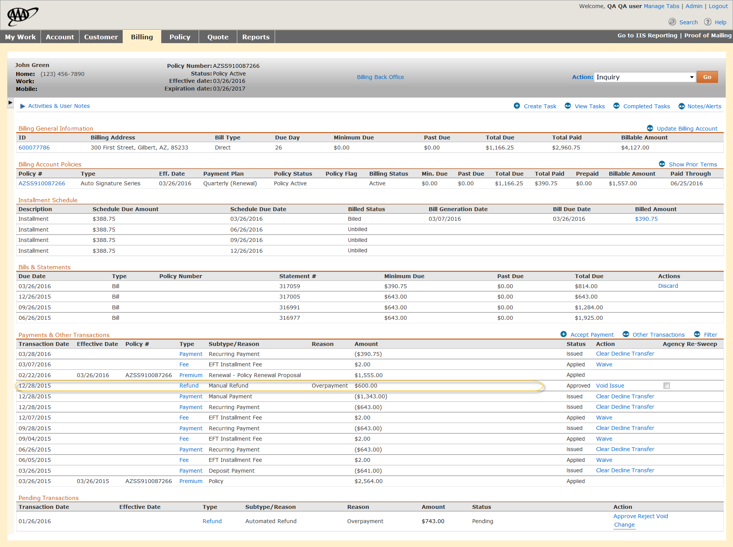

Transaction date logic-the date against which it is validated is DD9 which is 12/26/2015 (Saturday)

Actual date is 12/28/2015 (Monday)

RCA: weekend logic should have been handled.